Django Training Tasks

Task-1: Shopping Hub
Develop a Django-based Shopping Hub homepage that displays Amazon, Flipkart, and Meesho images with buttons linking to their official websites, along with a shopping-related video. Store HTML files in templates and images/videos in static folder.

Solution:

Views.py:

from django.shortcuts import render
from django.http import HttpResponse

def shopping(request):
return render(request, 'shopping.html')

urls.py:

from django.contrib import admin
from django.urls import path
from shopping import views

urlpatterns = [
path('shopping/',views.shopping),
path('admin/', admin.site.urls),]

Output:


Task-2: Student Registration Portal
Develop a Django-based Student Registration Portal with Signup, Login, and Student Registration pages. Store user and student details in the database using Django Models and Admin, and display a confirmation page after successful registration with options to register another student or return home.
Solution:

Views.py:

from django.shortcuts import render, redirect
from .models import User, Student

def home(request):
return render(request, "home.html")
def signup(request):
return render(request, "signup.html")
def saveuser(request):
if request.method == "POST":
username = request.POST.get("username")
password = request.POST.get("password")
name = request.POST.get("name")
if User.objects.filter(username=username).exists():
return render(request,"signup.html",
{"errormsg": "Username already exists. Please login."})

User.objects.create(username=username, password=password, name=name)
return redirect("login")
return redirect("signup")
def login(request):
return render(request, "login.html")
def loginvalidation(request):
if request.method == "POST":
username = request.POST.get("username")
password = request.POST.get("password")
user = User.objects.filter(username=username, password=password).first()
if user:
request.session["username"] = user.username
return redirect("studentregistration")
else:
return render( request,"login.html",{
"errormsg": "Invalid username or password."})
return redirect("login")
def studentregistration(request):
if "username" not in request.session:
return redirect("login")
return render(request, "studentregistration.html)
def savestudent(request):
if request.method == "POST":
student_name = request.POST.get("student_name")
student_id = request.POST.get("student_id")
branch = request.POST.get("branch")
Student.objects.create(student_name=student_name, student_id=student_id, branch=branch)
return redirect("success")
return redirect("studentregistration")
def success(request):
return render(request,"success.html")
models.py:

from django.db import models
class User(models.Model):
username = models.CharField(max_length=100, unique=True)
password = models.CharField(max_length=100)
name = models.CharField(max_length=100)
def __str__(self):
return self.username
class Student(models.Model):
student_id = models.CharField(max_length=50, unique=True)
student_name = models.CharField(max_length=100)
branch = models.CharField(max_length=100)
def __str__(self):
return self.student_name

app/urls.py:

from django.urls import path
from .views import *
urlpatterns = [
path("", home, name="home"),
path("home/", home, name="home"),
path("signup/", signup, name="signup"),
path("saveuser/", saveuser, name="saveuser"),
path("login/", login, name="login"),
path("loginvalidation/",loginvalidation,name="loginvalidation"),
path("studentregistration/",studentregistration,name="studentregistration"),
path("savestudent/",savestudent,name="savestudent"),
path("success/",success,name="success"),]

main urls.py:

from django.contrib import admin
from django.urls import path
from django.urls import include

urlpatterns = [
path("studentPortal/",include("studentPortal.urls")),
path('admin/', admin.site.urls),]

Output:
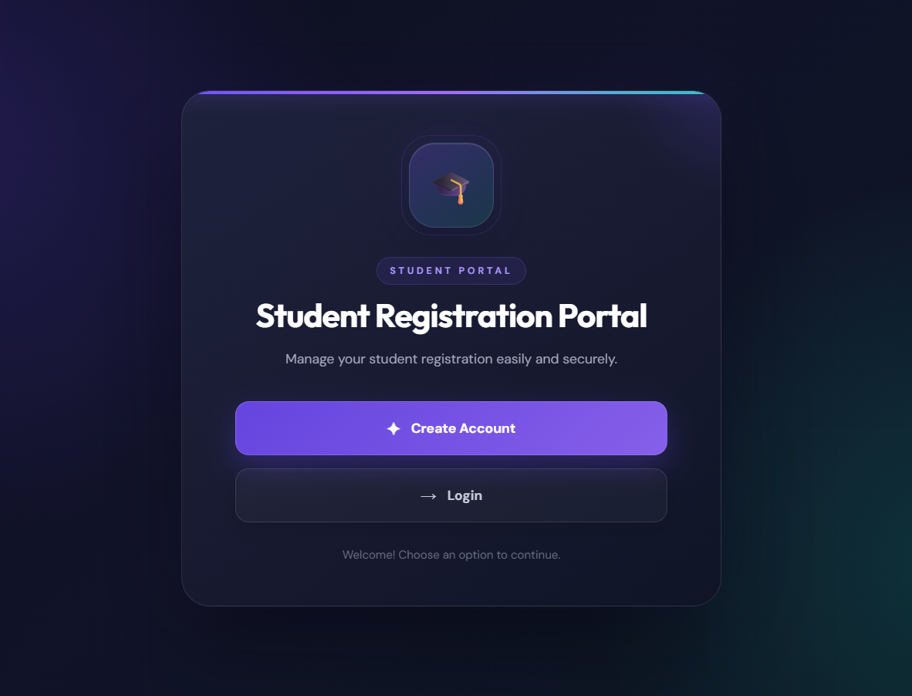
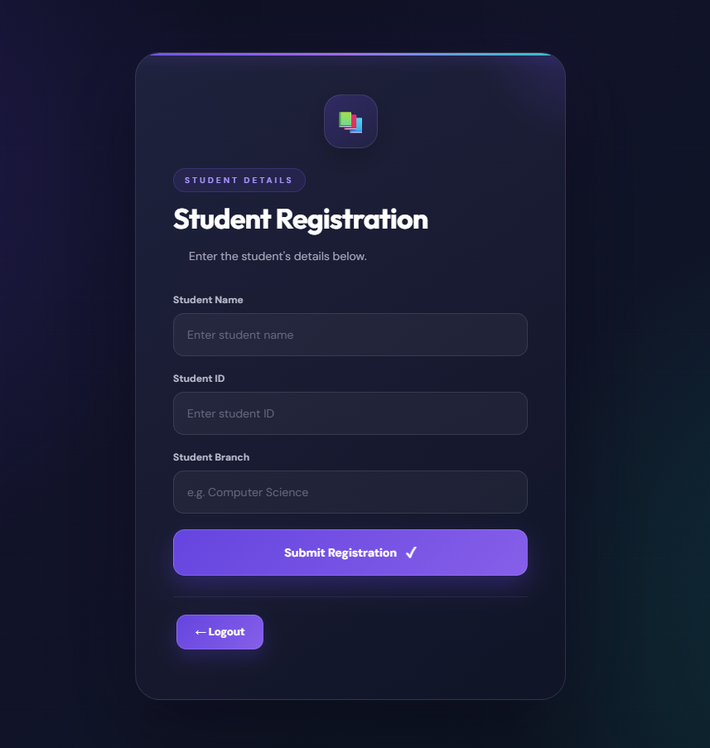

Task 3: Online Testing System
Develop a Django-based Online Testing System where students can register, log in, view and attempt MCQ tests, submit answers, view results, and track test history. Store student, test, question, and test-attempt details using Django Models and Admin.

Views.py:
from django.shortcuts import render, redirect, get_object_or_404
from django.contrib.auth import authenticate, login, logout
from django.contrib.auth.decorators import login_required
from django.contrib.auth.models import User
from .forms import SignUpForm, LoginForm
from .models import Question, TestResult
import random

def home(request):
if request.user.is_authenticated:
return redirect('welcome')
return render(request, 'home.html')
def signup(request):
if request.method == 'POST':
form = SignUpForm(request.POST)
if form.is_valid():
username = form.cleaned_data['username']
if User.objects.filter(username=username).exists():
form.add_error('username', 'Username already exists.')
else:
User.objects.create_user(username=username,
password=form.cleaned_data['password'],
first_name=form.cleaned_data['name'])
return redirect('login')
else:
form = SignUpForm()
return render(request, 'signup.html', {'form': form})
def user_login(request):
if request.method == 'POST':
form = LoginForm(request.POST)
if form.is_valid():
user = authenticate(
username=form.cleaned_data['username'],
password=form.cleaned_data['password'])
if user:
login(request, user)
return redirect('welcome')
else:
form = LoginForm()
return render(request, 'login.html', {'form': form})
def user_logout(request):
logout(request)
return redirect('home')
@login_required
def welcome(request):
return render(request, 'welcome.html')
@login_required
def take_test(request, num):
questions = list(Question.objects.all())
if len(questions) < num:
return render(request, 'test.html', { 'not_enough_questions': True, 'num': num})
questions = random.sample(questions, num)
if request.method == 'POST':
correct = 0
attempted = 0
for q in questions:
answer = request.POST.get('q' + str(q.id))
if answer:
attempted += 1
if int(answer) == q.correct_option:
correct += 1
result = TestResult.objects.create(user=request.user,
test_type=num, total_questions=num,
attempted=attempted, correct=correct,
wrong=attempted - correct)
return redirect('result', result_id=result.id)
return render(request, 'test.html',{'questions': questions, 'num': num})
@login_required
def result(request, result_id):
result = get_object_or_404(TestResult, id=result_id, user=request.user)
return render(request, 'result.html', {'result': result})
@login_required
def history(request):
results = TestResult.objects.filter(user=request.user)
return render(request, 'history.html', {'results': results})

models.py:

from django.db import models
from django.contrib.auth.models import User
class Question(models.Model):
OPTION_CHOICES = (
(1, 'Option 1'),
(2, 'Option 2'),
(3, 'Option 3'),
(4, 'Option 4'),)
question_text = models.CharField(max_length=500)
option1 = models.CharField(max_length=200)
option2 = models.CharField(max_length=200)
option3 = models.CharField(max_length=200)
option4 = models.CharField(max_length=200)
correct_option = models.IntegerField(choices=OPTION_CHOICES)
def __str__(self):
return self.question_text
def options(self):
return [(1, self.option1),
(2, self.option2),
(3, self.option3),
(4, self.option4),]
def correct_answer_text(self):
return dict(self.options())[self.correct_option]
class TestResult(models.Model):
user = models.ForeignKey(User, on_delete=models.CASCADE, related_name='results')
test_type = models.IntegerField(help_text='Number of questions in the test')
total_questions = models.IntegerField()
attempted = models.IntegerField()
correct = models.IntegerField()
wrong = models.IntegerField()
taken_on = models.DateTimeField(auto_now_add=True)
class Meta:
ordering = ['-taken_on']
def __str__(self):
return f'{self.user.username} - Test of {self.test_type} - {self.correct}/{self.total_questions}'
@property
def score_percent(self):
if self.total_questions == 0:
return 0
return round((self.correct / self.total_questions) * 100)
app/urls.py:

from django.urls import path
from . import views
urlpatterns = [
path('', views.home, name='home'),
path('signup/', views.signup, name='signup'),
path('login/', views.user_login, name='login'),
path('logout/', views.user_logout, name='logout'),
path('welcome/', views.welcome, name='welcome'),
path('test/<int:num>/', views.take_test, name='take_test'),
path('result/<int:result_id>/', views.result, name='result'),
path('history/', views.history, name='history'),]

main urls.py:

from django.contrib import admin
from django.urls import path, include
from django.conf import settings
from django.conf.urls.static import static
urlpatterns = [
path('admin/', admin.site.urls),
path('', include('onlinetest.urls')),]

Output:

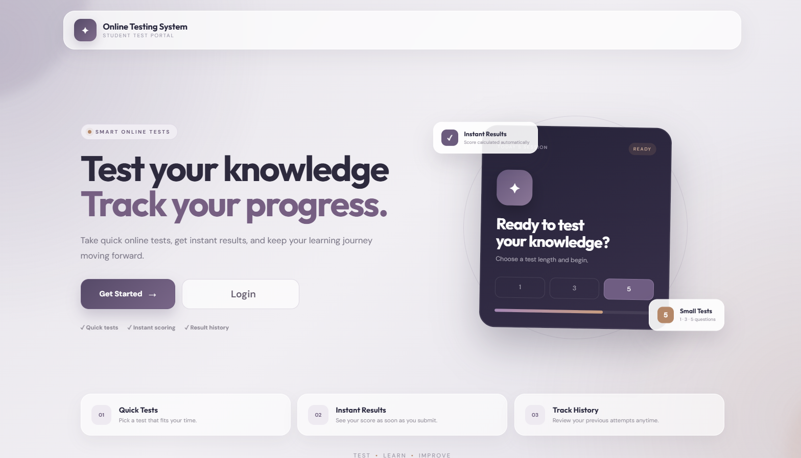
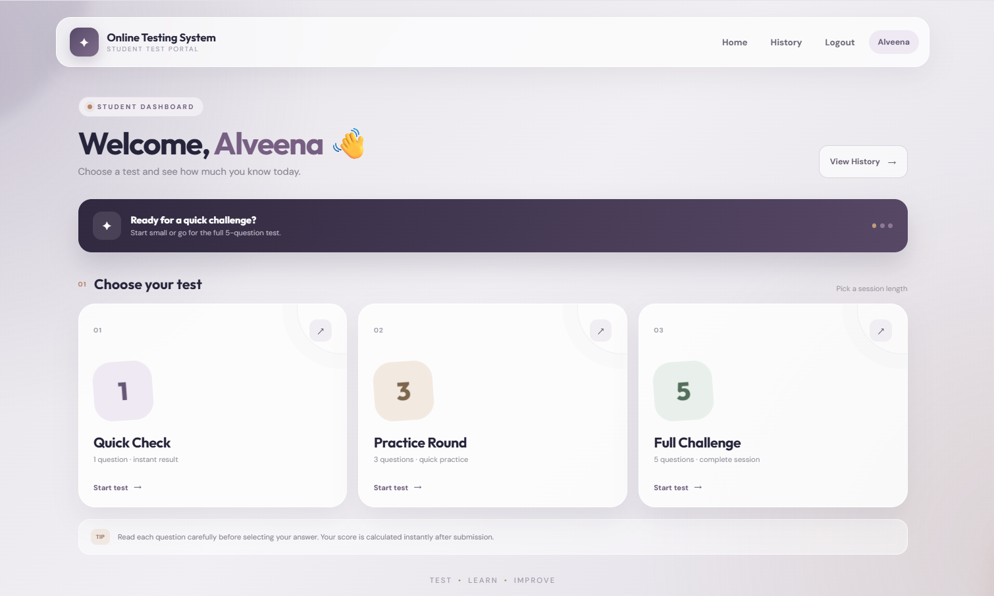

Task 4: Student Placement Prediction System
Develop a Django-based Student Placement Prediction System where students can register, log in, enter IQ, CGPA, and Profile Score, and use a Machine Learning model to predict their placement status. Store student details in the database and display the prediction on a Result page as Placed or Unplaced.
Views.py:

from django.shortcuts import render, redirect
from django.db import IntegrityError
from .models import Student
import joblib

def home(request):
return render(request, "home.html")
def studentregister(request):
if request.method == "POST":
data = {
"student_id": request.POST.get("student_id", "").strip(),
"name": request.POST.get("name", "").strip(),
"password": request.POST.get("password", ""),
"branch": request.POST.get("branch", "").strip(),
"student_number": request.POST.get("student_number", "").strip(),
"email": request.POST.get("email", "").strip().lower()}
if not all(data.values()):
return render(request, "studentregister.html", {"error": "Please fill all fields."})
if Student.objects.filter(student_id=data["student_id"]).exists():
return render(request, "studentregister.html", {"error": "Student ID already registered."})
if Student.objects.filter(email=data["email"]).exists():
return render(request, "studentregister.html", {"error": "Email already registered."})
try:
Student.objects.create(**data)
except IntegrityError:
return render(request, "studentregister.html", {"error": "Student details already exist."})
return redirect("login")
return render(request, "studentregister.html")
def login(request):
if request.method == "POST":
name = request.POST.get("name", "").strip()
password = request.POST.get("password", "")
student = Student.objects.filter(name=name, password=password).first()
if student:
request.session["student_id"] = student.student_id
request.session["student_name"] = student.name
request.session["student_branch"] = student.branch
return redirect("prediction")
return render(request, "login.html", {"error": "Invalid student name or password."})
return render(request, "login.html")
def prediction(request):
if "student_id" not in request.session:
return redirect("login")
return render(request, "prediction.html", {
"student_name": request.session.get("student_name"),
"student_branch": request.session.get("student_branch")})
def result(request):
if "student_id" not in request.session:
return redirect("login")
try:
iq = float(request.GET.get("iq", 0))
cgpa = float(request.GET.get("cgpa", 0))
profile_score = float(request.GET.get("profile_score", 0))
if iq <= 0:
raise ValueError("IQ must be greater than 0.")
if cgpa < 0 or cgpa > 10:
raise ValueError("CGPA must be between 0 and 10.")
if profile_score < 0:
raise ValueError("Profile score cannot be negative.")
scaler = joblib.load("scalermodel.pkl")
model = joblib.load("mlmodel.pkl")
data = [[iq, cgpa, profile_score]]
result = model.predict(scaler.transform(data))[0]
return render(request, "result.html", {
"ans": int(result),
"iq": iq,
"cgpa": cgpa,
"profile_score": profile_score,
"student_name": request.session.get("student_name"),
"student_branch": request.session.get("student_branch")})
except ValueError as e:
return render(request, "prediction.html", {
"error": str(e),
"student_name": request.session.get("student_name"),
"student_branch": request.session.get("student_branch")})
except Exception as e:
return render(request, "result.html", {
"model_error": True,
"error_message": str(e),
"student_name": request.session.get("student_name")})

Models.py:
from django.db import models

class Student(models.Model):
student_id = models.CharField(max_length=20,unique=True)
name = models.CharField(max_length=100)
password = models.CharField(max_length=100)
branch = models.CharField(max_length=100)
student_number = models.CharField(max_length=15)
email = models.EmailField(unique=True)

def __str__(self):
return self.name

app/urls.py:

from django.urls import path
from . import views

urlpatterns = [
path("", views.home, name="home"),
path("studentregister/",views.studentregister,name="studentregister"),
path("login/",views.login,name="login"),
path("prediction/",views.prediction,name="prediction"),
path("result/",views.result,name="result"),]
main urls.py:

from django.contrib import admin
from django.urls import include, path

urlpatterns = [
path("",include("studentpred.urls")),
path('admin/', admin.site.urls),]

Output: 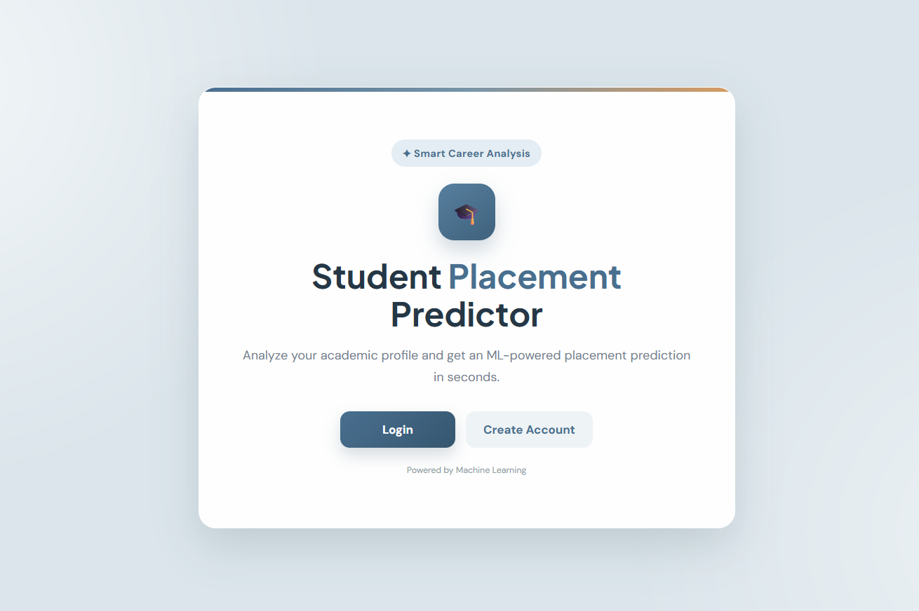
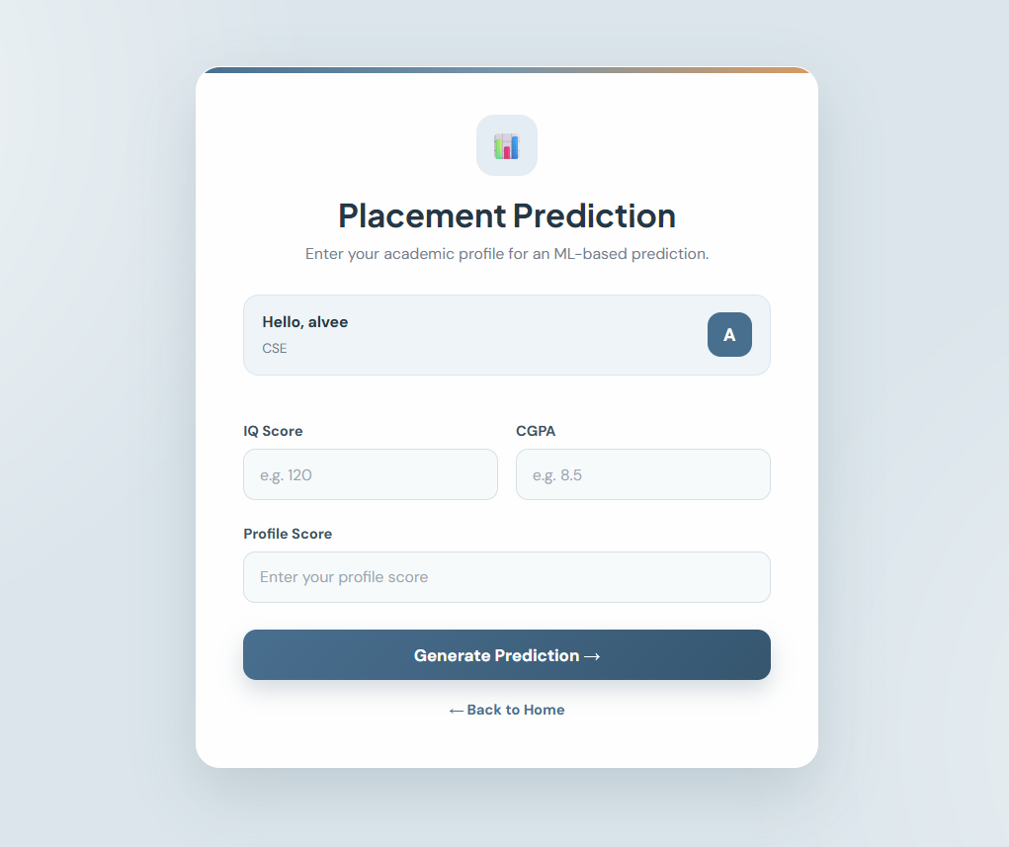

Task 5: Library Management System

Develop a Flask-based Library Management System with MySQL database connectivity that allows users to sign up, log in, issue books, view issued-book records, and store and retrieve library data from the database.

Requirements.txt:
Flask
SQLAlchemy
bcrypt
Flask_SQLAlchemy
mysqlclient
pymysql

app.py:

from flask import Flask, redirect, url_for, render_template, request, session
from flask_sqlalchemy import SQLAlchemy

app = Flask(__name__)

app.secret_key = "library123"
app.config['SQLALCHEMY_DATABASE_URI'] = 'mysql+pymysql://root:@localhost/LibraryManagement'
app.config['SQLALCHEMY_TRACK_MODIFICATIONS'] = False
db = SQLAlchemy(app)

class User(db.Model):
sno = db.Column(db.Integer, primary_key=True)
name = db.Column(db.String(80), nullable=False)
username = db.Column(db.String(50), unique=True, nullable=False)
password = db.Column(db.String(100), nullable=False)

class Book(db.Model):
sno = db.Column(db.Integer, primary_key=True)
book_id = db.Column(db.String(30), nullable=False)
book_name = db.Column(db.String(100), nullable=False)
book_number = db.Column(db.String(30), nullable=False)
student_name = db.Column(db.String(80), nullable=False)
issue_date = db.Column(db.String(20), nullable=False)
due_date = db.Column(db.String(20), nullable=False)
with app.app_context(): db.create_all()

@app.route('/')
def home(): return render_template('home.html')
@app.route('/signup', methods=['GET', 'POST'])
def signup():
if request.method == 'POST':
name, username, password = request.form['name'], request.form['username'], request.form['password']
if User.query.filter_by(username=username).first():
return render_template('signup.html', message='Username already exists')
db.session.add(User(name=name, username=username, password=password))
db.session.commit()
return redirect(url_for('login'))
return render_template('signup.html')
@app.route('/login', methods=['GET', 'POST'])
def login():
if request.method == 'POST':
username, password = request.form['username'], request.form['password']
user = User.query.filter_by(username=username, password=password).first()
if user:
session['username'], session['name'] = user.username, user.name
return redirect(url_for('dashboard'))
return render_template('login.html', message='Invalid username or password')
return render_template('login.html')
@app.route('/dashboard')
def dashboard():
if 'username' not in session: return redirect(url_for('login'))
return render_template('dashboard.html', name=session.get('name'))
@app.route('/issue-book', methods=['GET', 'POST'])
def issue_book():
if 'username' not in session: return redirect(url_for('login'))
if request.method == 'POST':
book_id = request.form['book_id']
book_name = request.form['book_name']
book_number = request.form['book_number']
student_name = request.form['student_name']
issue_date = request.form['issue_date']
due_date = request.form['due_date']
new_book = Book(book_id=book_id, book_name=book_name, book_number=book_number,
student_name=student_name, issue_date=issue_date, due_date=due_date)
db.session.add(new_book)
db.session.commit()
session['book_id'], session['book_name'] = book_id, book_name
session['student_name'], session['issue_date'] = student_name, issue_date
session['due_date'] = due_date
return redirect(url_for('success'))
return render_template('issue_book.html')
@app.route('/view-books')
def view_books():
if 'username' not in session: return redirect(url_for('login'))
books = Book.query.all()
return render_template('view_books.html', books=books)
@app.route('/success')
def success():
if 'username' not in session: return redirect(url_for('login'))
return render_template('success.html', book_name=session.get('book_name'),
student_name=session.get('student_name'),
issue_date=session.get('issue_date'),
due_date=session.get('due_date'))
@app.route('/logout')
def logout():
session.clear()
return redirect(url_for('home'))

if __name__ == '__main__': app.run(debug=True)

Output:

